.
🛠 Mermaids.js: Diagrams as Code Practice

.
we are moving away from heavy modeling tools and focusing on Diagrams as Code (DaC) using Mermaid.js.
In modern DevOps and Agile environments, we want our documentation to live alongside our code. Mermaid.js allows you to render Markdown-inspired text into complex diagrams. This ensures your software design remains version-controlled and easy to update without needing a graphic designer.

.

Lab Setup: Getting Started

.
You have two primary ways to use Mermaid.js. For this practice, we will start with the Live Editor and move to an Integrated Development Environment (IDE).

Option A: The Mermaid Live Editor (Beginner)
- Go to Mermaid.live.
- This is a web-based GUI where you can type code on the left and see the diagram on the right.

Option B: VS Code Extension (Professional Standard)
- Open VS Code.
- Go to the Extensions view (Ctrl+Shift+X).
- Search for and install "Mermaid Editor" or "Markdown Preview Mermaid Support".
- Create a new file named practice.md.
- Wrap your mermaid code in a code block like this:
```mermaid
[Your Code Here]
```

.

Level 1: Beginner – Class Diagrams

.
Class diagrams describe the static structure of a system. We will model a simple Library Management System.

Key Syntax:
- classClassName: Defines a class.
- <|--: Inheritance (Is-a).
- *--: Composition (Has-a).
- +: Public / -: Private.

Step 1: Define the Classes
Copy this into your editor:
Code snippet
classDiagram
class Book {
-String title
-Boolean isAvailable
+checkOut()
+isAvailable() Boolean
}
class Member {
+String name
+borrowBook(Book b)
}

class Library {
+List books
+addBook(Book book)
}

Library "1" *-- "many" Book : contains
Member "1" --> "0..*" Book : borrows

- Composition (*--): The Library "owns" the books. If the library closes, the book collection (in this context) ceases to exist as a managed unit.
- Multiplicity ("1" *-- "many"): Indicates one library holds many books.

Class Diagram
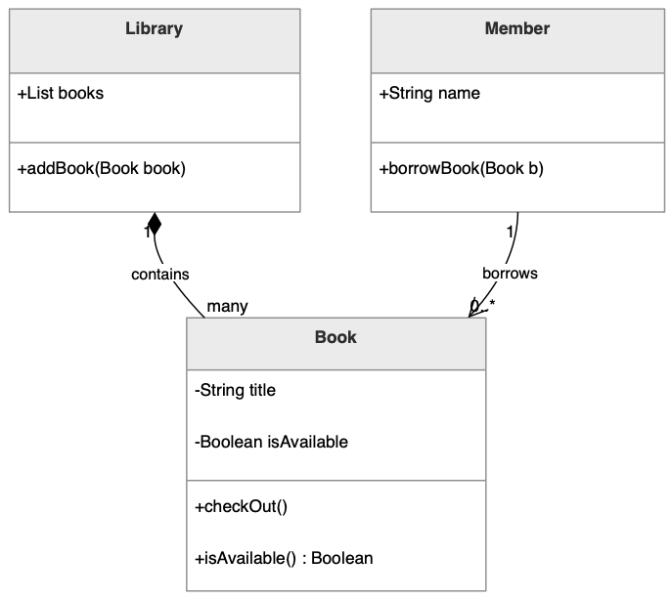

.

Level 2: Intermediate – Sequence Diagrams

.
Sequence diagrams model the dynamic behavior—how objects interact over time. We will model the "Checkout Process".

Key Syntax:
- participant: Defines an object or actor.
- ->>: Synchronous message.
- -->>: Response message.
- alt/else: Conditional logic (if/then).

Step 2: Modeling the Interaction
Add this below your class diagram:
Code snippet
sequenceDiagram
participant M as Member
participant B as Book

M->>B: isAvailable()
activate M
activate B
B-->>M: true
deactivate B
deactivate M

M->>B: checkOut()
activate M
activate B
Note right of B: Internal state: isAvailable = false
B-->>M: success
deactivate B
deactivate M

Observation Task:
Notice the Activation Boxes (the vertical bars). You can add activate S and deactivate S to show exactly when a process is consuming memory or processing power.
Sequence Diagram
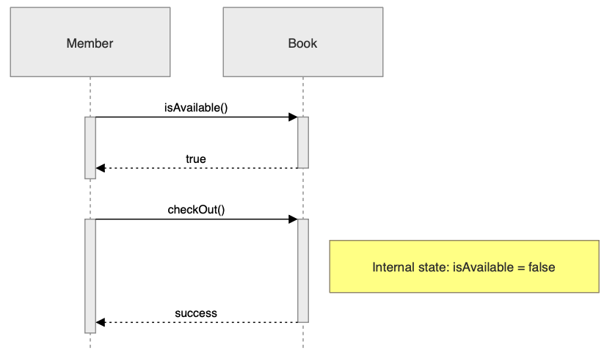

.

Level 3: Advanced – Software Design Integration

.
In a professional environment, we use these diagrams to explain complex architectures, such as Microservices or API Gateways.

.

📍 The Scenario: E-Commerce Payment Gateway

.
We need to design a system where a User pays for an order. The Order Service must talk to a Payment Service, which validates with an External Bank API.

Advanced Class Diagram with Generics and Annotations:
Code snippet
classDiagram
class OrderService {
+validateOrder(orderId) Boolean
}
class PaymentService {
+processTransaction(amount) String
+checkBankStatus() String
}
OrderService ..> PaymentService : uses

Class Diagram

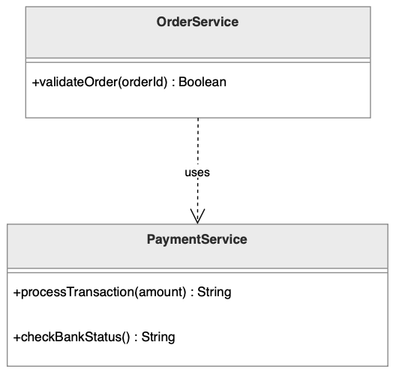

Advanced Sequence Diagram with Notes and Loops:
Code snippet
sequenceDiagram
autonumber
actor User
participant Gateway
participant Order as OrderService
participant Pay as PaymentService

User->>Gateway: Submit Payment Details
activate User
activate Gateway

Gateway->>Order: validateOrder(id)
activate Order
Order-->>Gateway: true
deactivate Order

rect rgb(240, 240, 240)
Note right of Pay: Encrypting Data
Gateway->>Pay: processTransaction(total)
activate Pay
loop Every 2 seconds
Pay->>Pay: checkBankStatus()
end
Pay-->>Gateway: "Authorized"
deactivate Pay
end

Gateway-->>User: Show "Success" Screen
deactivate Gateway
deactivate User

Sequence Diagram (Low-Level Design)

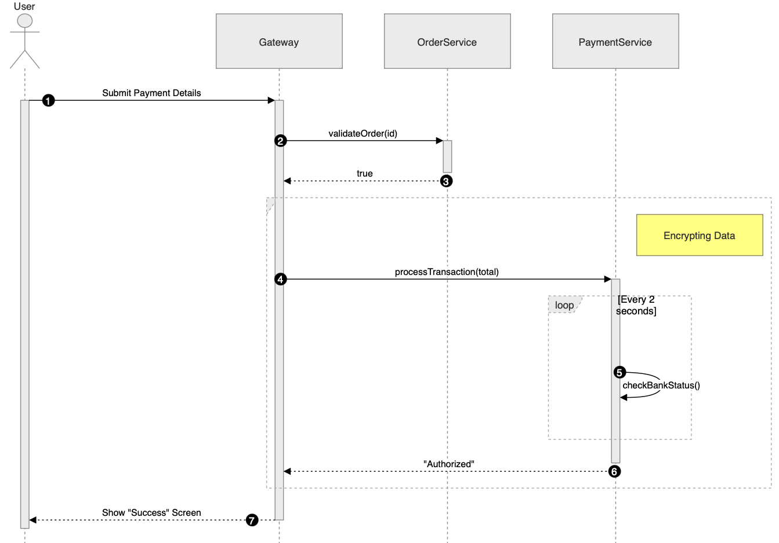

Sequence Diagram (High-Level Design)



.

Student Practice Task

.
In-class Assignment:
Create a single Markdown file containing a Class Diagram and a Sequence Diagram for a Hospital Management System.
- Class Diagram Requirements:
  - Classes for Doctor, Patient, and Appointment.
  - Doctor should have a method diagnose().
  - Use inheritance if you add Specialist doctors.

classDiagram

class Person{
+String name
}

class Doctor{
-diagonose()
-create_an_appointment(Patient patient, String date) : Appointment
%%suppposed to have : Appointment appointment after this

}

class Patient{
+String sickness
+report_condition(Doctor doctor) : String
+leave()
}

class Specialist{
+String type_of_specialist
-specialized_diagnosis()
}

class Appointment{
+String patient_name
+String sickness
+String date
+send_an_appointment(Patient patient) : Appointment

}

Doctor --|> Person
Patient --|> Person
Specialist --|> Doctor
Doctor "1" --> "0..*" Appointment : create an appointment
Patient "1" <-- "0..*" Appointment : receive an appointment
Patient "1" --> "1" Doctor : report condition

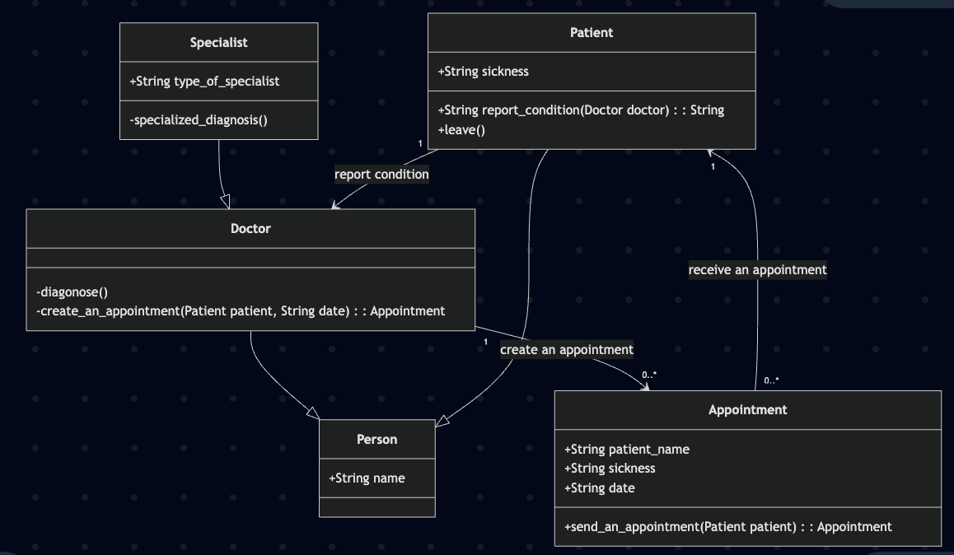

sequenceDiagram

participant patient
participant doctor
participant medMan as medical_management
participant appointment

patient ->> doctor: reportSickness()
activate patient
activate doctor
activate medMan
doctor ->> medMan: send_medical_report()
deactivate doctor
medMan -->> patient : provide_medicine()

deactivate patient
deactivate medMan

patient ->> doctor : makeAppointment()
activate patient
activate doctor
activate appointment
doctor -->> patient : informDateTime()
alt not_available
patient -->> doctor : informCantCome()
doctor ->> patient : reschedule()
patient ->> doctor : confirmReschedule()
else available
patient ->> doctor : confirm()
doctor ->> patient : confirm()

end
doctor ->> appointment : makeAnAppointment()
appointment -->> patient : informAppointment()

deactivate patient
deactivate doctor

activate patient
activate doctor
Opt goodbye
patient ->> doctor : goodbye()
activate patient
activate doctor
doctor ->> patient : goodbye()

end
deactivate patient
deactivate doctor

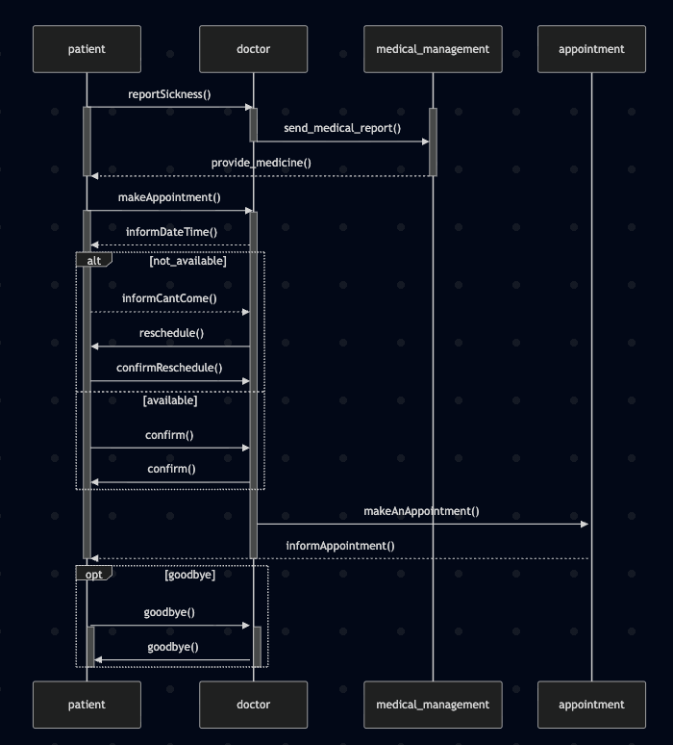

- Sequence Diagram Requirements:
  - The Patient books an Appointment.
  - The Patient checks the Doctor's schedule.
  - Include an alt block for if the doctor is busy vs. available.
Submission: Export your diagrams as .png files from the Live Editor or submit the .md source code via the university portal.

